Secure Software Design Coursework

Design
This is a C++ application written with the intention of monitoring a Greenhouse. It allows a given user to monitor the temperature, humidity and dewpoint temperature. Based on the given temperature a fan will be automatically activated to keep under it’s given activation temperature. The sensors collect information in Fahrenheit and then convert it into Celsius before passing back to the user. An admin of the system, password required (1234), can configure the options of appropriate sensors/actuator(s) to their liking.

Patterns
There are 2 design patterns employed in this project, a Secure Logger pattern and an MVC pattern.
My reasoning for selecting these 2 patterns is to keep a secure and readable format to the project and also allow for easy information logging/saving. Below I will show the UML designs of the patterns and how they interact and then go into more detail on the benefits they have.

MVC
An MVC patter, or Model View Controller, is a popular pattern used in modern programming. It separates what the user can see and interact with [View] from the inner workings/core functionality of the program [Model] via the implementation of a middle class or a [Controller].
This circumvents the likelihood of someone being able to perform malicious attacks against the system and potentially leak private information, potentially destroying not only the lives of those of concern but also drastically affecting the reputation of the company and its staff team.
The Controller interacts between the Model and the View classes to co-ordinate the program whilst maintaining a more secure relationship, an addition to this is it makes for a very modular program which is beneficial when working in larger groups. For example, someone can do work on just the frontend or ‘View’ without affecting the actual functionality of the entire project. This both increases maintainability and also flexibility.
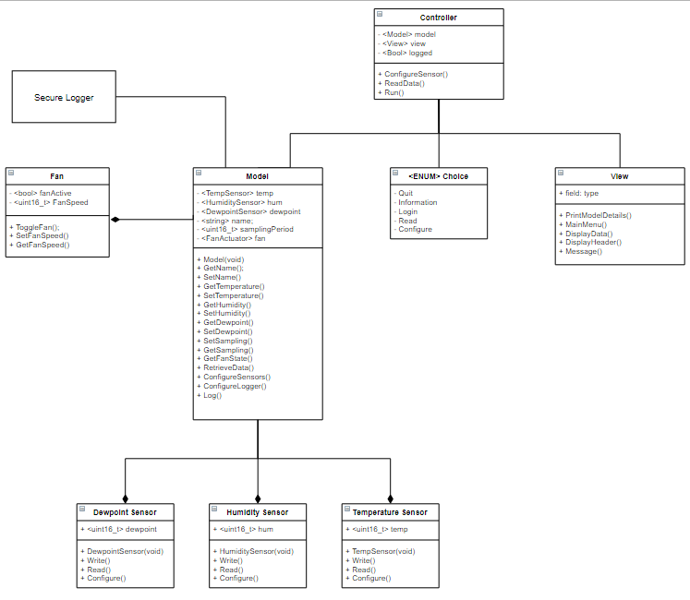
Secure Logger
The Secure Logger pattern allows for easy storing of information whilst incorporating different file types and formatting. In the case of my logger pattern I have a ‘.txt. logger file and also functionality to log to console should the user wish to, in addition to this I have also implemented an XOR encryption to increase safety should the user wish to.
This implementation proves the use of the secure logger and its capability, I completed the MVC and then incorporated the secure logger afterwards. Again, maintaining the modular design, I intended to create when using the MVC pattern. The capability to ‘plug and play’ when developing software is incredibly useful during all stages of development.

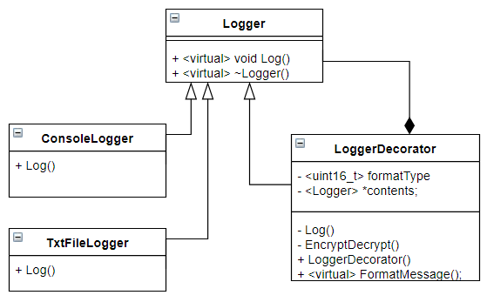

Security Practices

Title | Dangling Pointers:
Description | Dangling pointers are circumvented entirely when using unique_ptr, this is due to their automatic functionality of deleting themselves after no longer in use. This removes the pointer from memory thus also leaving no trace of it behind.
Example

Title | Integer Safety
Description | The usual ‘int’ data type is prone to many errors, if someone were able to overload the int value it would leave a window for potential malicious code injection into the systems memory. Again, to circumvent this the use of a different data type ‘uint16_t or uint32_t’.  The ‘uint16_t or uint32_t’ prevents integer wraparound and also likelihood of overflow.
Example

Title | Std::string
Description | The use of the string datatype is a safety in its own right, although at core it is just an array of characters, the implementation of the string data type has improved type safety dramatically in code. Mainly due to the ease in which it is to use, whilst also securing the variable.
Example

Title | File Safety
Description | File IO has become very saturated within the C++ library due it being such an old language, many checks can be performed to secure the safety of IO when using files.  The ‘.fail()’ method will return true/false depending if the file has been opened successfully this is the first check to employ.  The ‘Try-Catch’ method has also been used here, this will prevent the program from stopping during its execution and instead alert the user of a given error. This increases reliability of the system and also gives the user chance to fix any errors they may have had on their end.
Example | 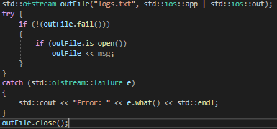

Title | Formatted IO
Description | IO is one of the bigger concerns with a program of this nature, thankfully since most of the IO is limited formatting it is relatively straightforward.  The code block below will not exit unless an appropriate value is given by the user, if the values were invalid of any sort the ‘cin’ buffer is flushed and a new input is required.
Example | 